

P: 6176 3470
Information about Retinitis Pigmentosa
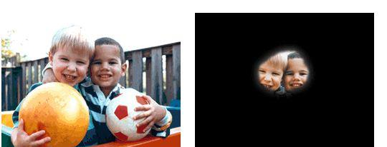

Normal Vision Vision with Retinitis Pigmentosa

What is Retinitis Pigmentosa?
Retinitis Pigmentosa (RP) is a genetic eye condition that causes the light-sensitive retina, located at the back of the eye, to degenerate slowly and progressively
The condition can vary greatly. While many people with RP retain limited vision through their lives others will lose their sight completely.

What are the symptoms?
Generally, symptoms develop between the ages of 10 and 30. Some of the first signs may include the following:
- Difficulty seeing at night (night-blindness) or in dimly lit areas.
- A narrowing field of vision.
- Light and glare sensitivity.

Who is at risk?

RP is a hereditary disease that occurs in people that have a family history of the condition. It often affects males more than females.

Can it be treated?
There is currently no standard treatment or therapy for RP. However, scientists have isolated several genes responsible for the disease. Once RP is discovered, patients and their families are encouraged to seek genetic counselling.

Our Mission at Eyes for Life Canberra
To maximise the personal resources and ability of people in the ACT whose lives are affected by blindness or low vision, by responding to their needs through care, communication and support.

Need assistance:

Contact Eyes for Life Canberra on 02 6176 3470

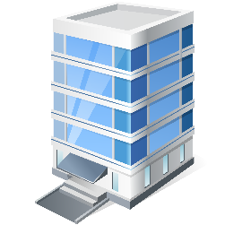
Visit Eyes for Life Canberra at The Griﬃn Centre:
20 Genge Street, Canberra ACT 2601

