

P: 6176 3470
Information about Macular Degeneration
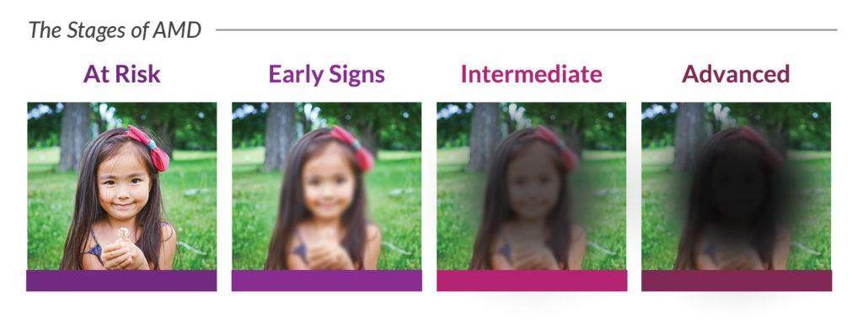

What is age-related macular degeneration?
Age-related macular degeneration (AMD) is the leading cause of severe vision impairment in older Australians.
AMD occurs when central vision deteriorates, making reading, close work and recognising faces more difficult.
The most common forms of the condition are Dry and Wet AMD. Dry AMD results in a gradual loss of central vision and Wet AMD leads to sudden and significant changes in vision.

What are the symptoms?
Common signs associated with AMD include:
- A gradual decline in the ability to see objects clearly
- Distorted vision
- Dark or empty spaces blocking the central field of vision
- Dimming of colour vision

Who is at risk?

Those most at risk of developing AMD are people with a family history of the condition, people over the age of 75 and smokers.

Can it be treated?
Early detection can make it possible to treat some types of AMD. Treatment for Wet AMD includes laser therapy. Other medical procedures such as radiotherapy and cortisone injections are also being tested.

Our Mission at Eyes for Life Canberra
To maximise the personal resources and ability of people in the ACT whose lives are affected by blindness or low vision, by responding to their needs through care, communication and support.

Need assistance:

Contact Eyes for Life Canberra on 02 6176 3470

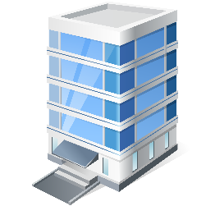
Visit Eyes for Life Canberra at The Griﬃn Centre:
20 Genge Street, Canberra ACT 2601

