

P: 6176 3470
Information about Diabetic Retinopathy

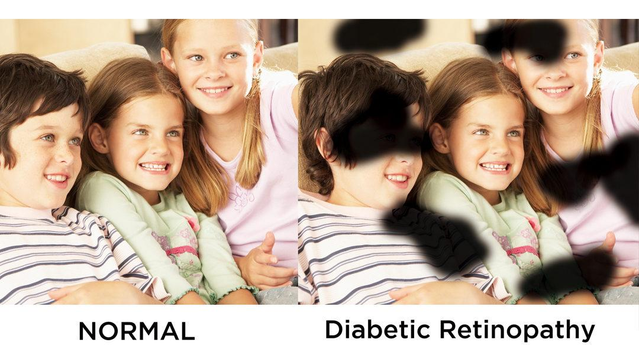

What is Diabetic Retinopathy?
Diabetic retinopathy occurs when the tiny blood vessels inside the retina at the back of the eye are damaged. This can seriously affect vision and in some cases may even cause blindness.

What are the symptoms?
Common symptoms include:
- Blurred or distorted vision that makes it difficult to read standard print, watch television or see people’s faces.
- Increased sensitivity to glare and difficulty seeing at night.

Who is at risk?
- People who have diabetes are at risk especially if they have:
- High blood-sugar levels or poorly managed diabetes.
- High blood pressure, particularly if they also have kidney disease
- A long history of the illness.

Can it be treated?
Laser and other surgical procedures can be conducted to treat diabetic retinopathy. This slows progression of the disease and decreases the risk of vision loss.
- People with diabetes should ensure they:
- See an eyecare professional regularly.
- Take prescribed medicines as instructed.
- Control blood-sugar levels and follow a healthy diet.

Our Mission at Eyes for Life Canberra
To maximise the personal resources and ability of people in the ACT whose lives are affected by blindness or low vision, by responding to their needs through care, communication and support.

Need assistance:

Contact Eyes for Life Canberra on 02 6176 3470


Visit Eyes for Life Canberra at The Griﬃn Centre:
20 Genge Street, Canberra ACT 2601

