

P: 6176 3470
Information about Nystagmus


Normal Vision with Nystagmus

What is Nystagmus?
Nystagmus refers to rapid involuntary movements that may cause one or both eyes to move from side to side, up and down or around in circles. The condition is caused by abnormal function in the areas of the brain that control eye movements. Nystagmus may be either present at birth or develop later in life.

What are the symptoms?
Nystagmus leads to low vision and may even cause legal blindness. Symptoms include:
- Blurred vision.
- Reduction in depth perception.

Can it be treated?

In rare cases eye muscle surgery can be performed which reduces the extent of eye movement.
Vision can also be improved through null point training, where an eye care professional works with the person to train their eyes in the direction where vision is the clearest.
The use of a magnifier and other low vision aids may be useful for people with Nystagmus.

Our Mission at Eyes for Life Canberra
To maximise the personal resources and ability of people in the ACT whose lives are affected by blindness or low vision, by responding to their needs through care, communication and support.

Need assistance:

Contact Eyes for Life Canberra on 02 6176 3470

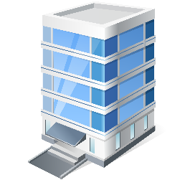
Visit Eyes for Life Canberra at The Griﬃn Centre:
20 Genge Street, Canberra ACT 2601

