

P: 6176 3470
Information about Glaucoma
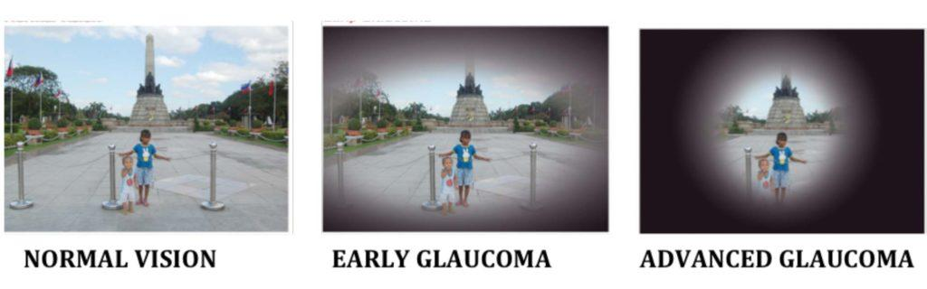

What is glaucoma?
Glaucoma is a condition associated with pressure in the eye. It is characterised by damage to the optic nerve that causes peripheral vision loss.

What are the symptoms?
Glaucoma often has no symptoms. However, common signs include:
- Severe pain and vision loss.
- Blurred vision, or seeing coloured rings around lights.
- Nausea and vomiting.

Who is at risk?
Those most at risk include people who have:
- A family history of the eye condition.
- Diabetes.
- An injury to the eye.
- Used steroids regularly over a long period of time.

Can it be treated?
Glaucoma can be treated with:
- Laser work
- Medication
- Surgery
Early detection and treatment of this condition can prevent or delay vision loss.
To help avoid glaucoma, people should have their eyes regularly examined by an eye care professional. Those in high-risk categories should have their eyes examined well before the age of 35.

Our Mission at Eyes for Life Canberra
To maximise the personal resources and ability of people in the ACT whose lives are affected by blindness or low vision, by responding to their needs through care, communication and support.

Need assistance:

Contact Eyes for Life Canberra on 02 6176 3470


Visit Eyes for Life Canberra at The Griﬃn Centre:
20 Genge Street, Canberra ACT 2601

